**SPIDER SOFTWARE TASK-1**

**COMMON TASK – OS**

**1. Process Management:**

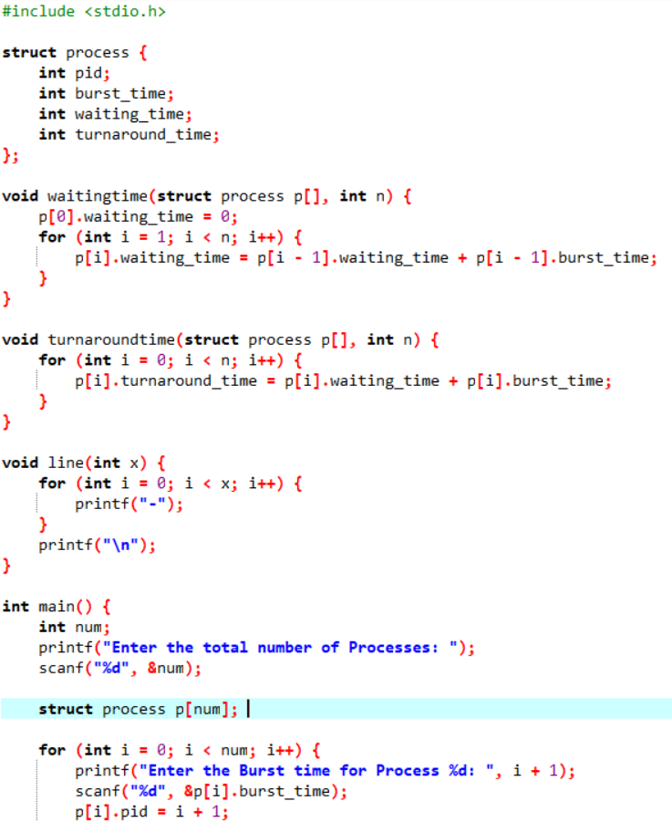

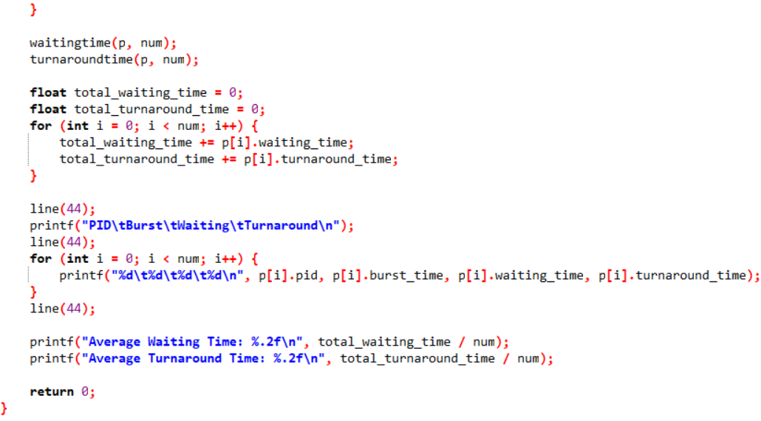

**Output**

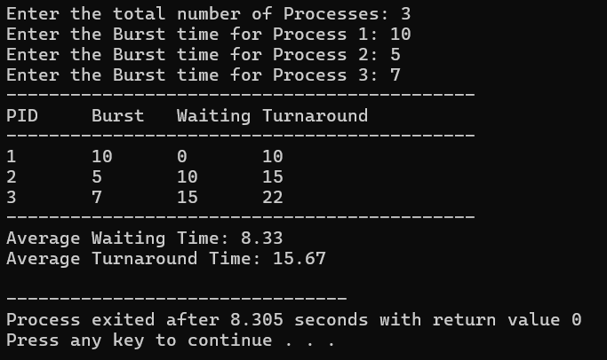

Process scheduling determines the order in which processes are given access to the CPU for execution. Scheduling algorithms, such as First Come First Serve (FCFS), play a crucial role in managing the execution order. FCFS scheduling is the simplest type of scheduling algorithm where processes are executed in the order they arrive in the queue. This is a non-preemptive as each process is given the CPU based on arrival time.

**Waiting Time:**

Waiting time is the total time a process spends in the queue waiting to be executed by the CPU. It does not include the time a process spends executing on the CPU or doing I/O operations.

**Turnaround Time:**

Turnaround time is the time that includes both the waiting time and the burst time of the process.

**2. Deadlock Handling**

Using Banker’s Algorithm to check the deadlock possibility

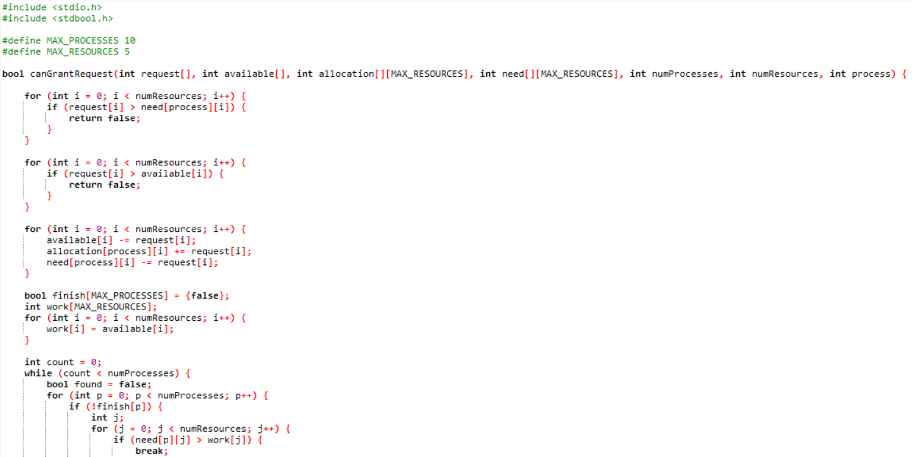

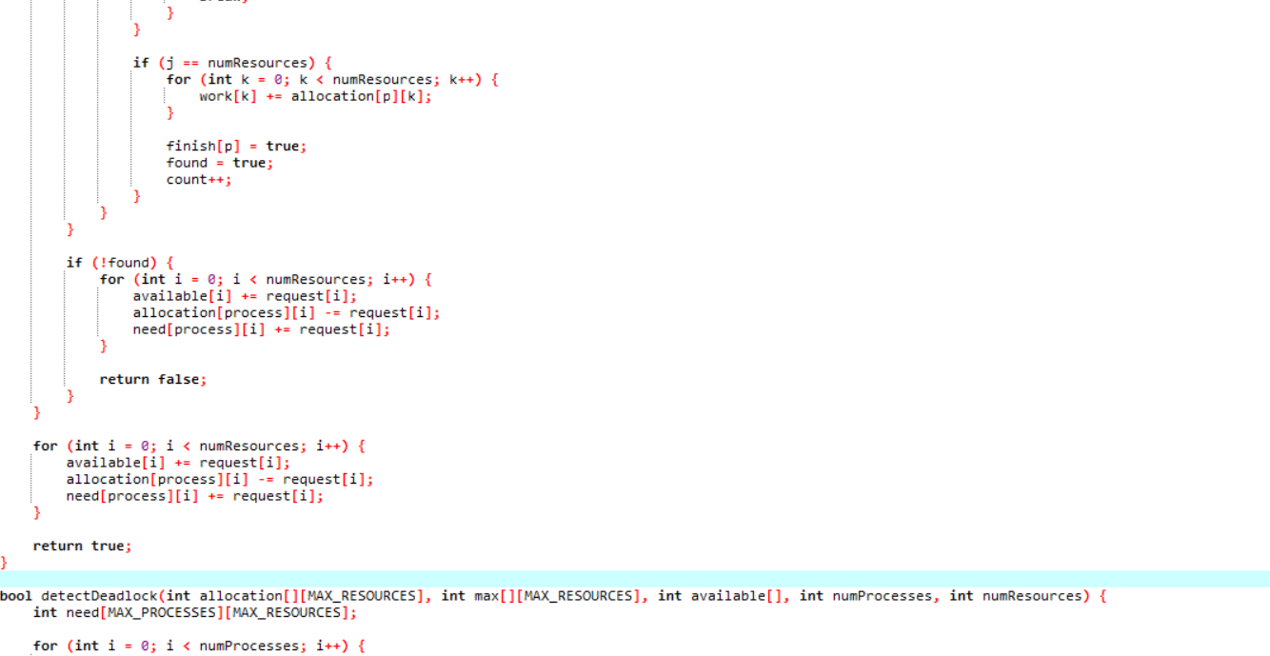

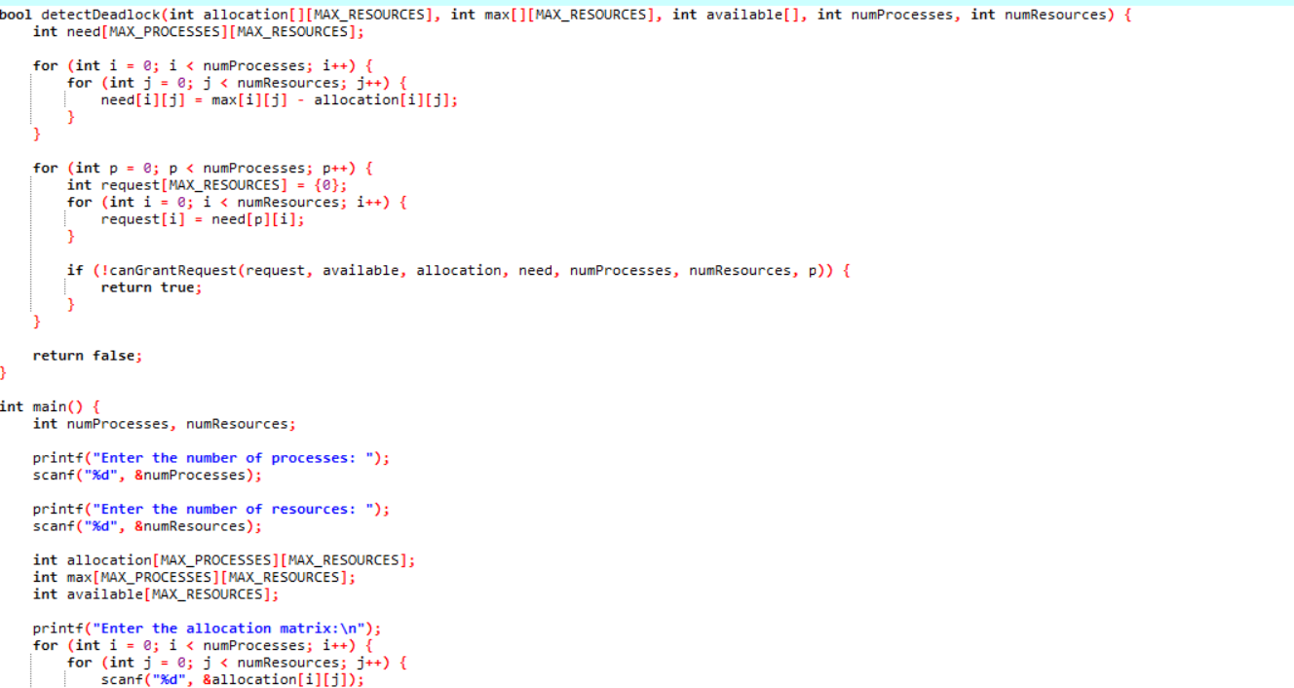

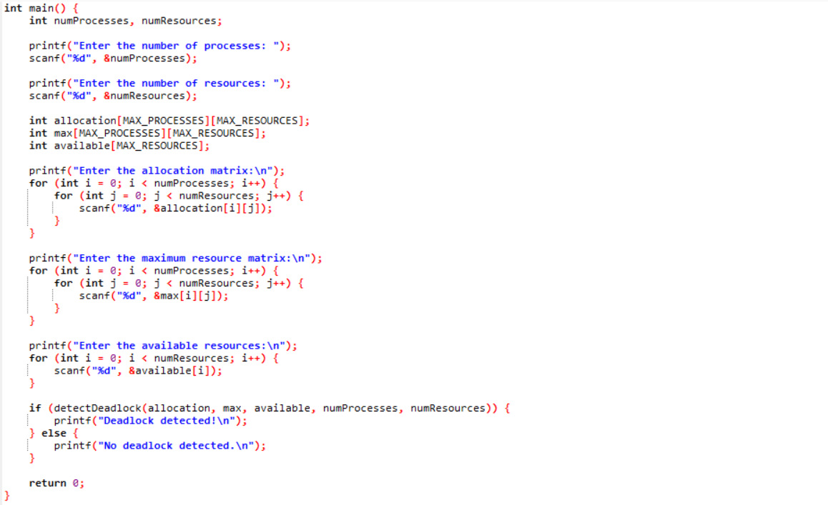

**Output**

